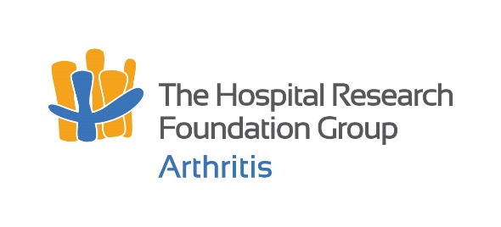


2024 Postgraduate Rheumatology Grant
Application Certification

Applicant Details:
Applicant’s Full Name: | Click or tap to enter Applicant’s name.
SmartyGrants Application ID: | Click or tap to enter ID.

Head of Department / Organisational Unit:
Title: Click to enter Title. | Full Name: Click to enter Full Name.
Department: Click to enter Department name.
By signing below, I certify that the appropriate general facilities will be available to the applicant if successful.
Signature: |  | Date: Click or tap to enter a date.

Administering Institution Nominee:
The Administering Institution certification from an appropriately authorised delegate can be arranged by contacting the Research Office at the applicant’s enrolling institution.
Title: Click to enter Title. | Full Name: Click to enter Name.
Institution: Click to enter Institution name.
Position: Click to enter position.
By signing below, I certify that the application is accurate, complete, and meets the requirements of this institution, and I endorse its submission.
Signature: |  | Date: Click or tap to enter a date.

Please return this statement to the applicant for inclusion in their application.
Applications close Wednesday 2nd October 2024, 4:00PM ACST

